Summer model – fit5 -- plots

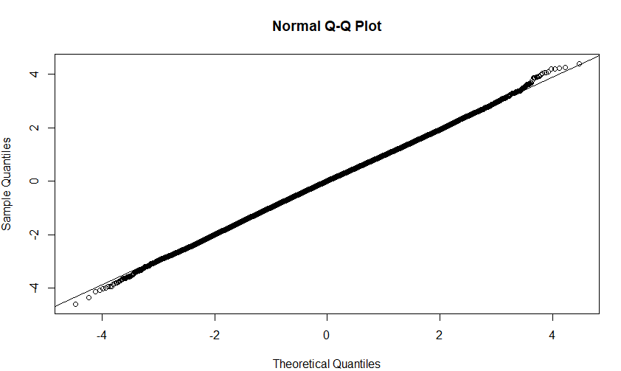

QQplot with mcmc (the slow but more robust way)

